Self-Pruning Neural Network
CIFAR-10 Image Classification — Tredence Analytics Case Study | AI Engineer

1. Objective
Design and train a neural network that learns to prune its own weights during training — without any post-training pruning step. Each weight in the network is paired with a learnable gate; L1 regularisation on the gate values continuously pushes redundant connections toward zero while allowing essential ones to remain active. The network therefore discovers its own sparse topology end-to-end.

2. Architecture
The network is a 4-layer fully-connected feedforward network. CIFAR-10 images (32×32×3) are flattened to 3,072-dimensional vectors and passed through three hidden layers, each followed by Batch Normalisation and ReLU activation, before reaching the 10-class output layer.

Layer | Type | Input → Output | Activation
fc1 | PrunableLinear | 3072 → 1024 | BatchNorm → ReLU
fc2 | PrunableLinear | 1024 → 512 | BatchNorm → ReLU
fc3 | PrunableLinear | 512 → 256 | BatchNorm → ReLU
fc4 | PrunableLinear | 256 → 10 | — (logits)

Total learnable gate parameters: ~3.8 million (one per weight element across all four layers).

3. Gating Mechanism

PrunableLinear Layer
Every standard weight in a Linear layer is replaced by a gated weight: a learnable gate_score parameter of the same shape is introduced, passed through a sigmoid, and multiplied element-wise with the weight before the linear operation.

class PrunableLinear(nn.Module):
def __init__(self, in_features: int, out_features: int) -> None:
super().__init__()
self.weight = nn.Parameter(torch.empty(out_features, in_features))
self.bias = nn.Parameter(torch.zeros(out_features))
self.gate_scores = nn.Parameter(torch.full((out_features, in_features), 0.5))
nn.init.kaiming_uniform_(self.weight, nonlinearity='relu')

def forward(self, x: torch.Tensor) -> torch.Tensor:
gates = torch.sigmoid(self.gate_scores)
return F.linear(x, self.weight * gates, self.bias)

def get_gates(self) -> torch.Tensor:
"""Detached gate values for diagnostics."""
return torch.sigmoid(self.gate_scores).detach()

Design Decisions
Component | Implementation | Rationale
weight | nn.Parameter | Learns the actual weight magnitudes
gate_scores | nn.Parameter, same shape as weight | Learnable gates; initialised to 0.5 so sigmoid ≈ 0.62
Activation | Sigmoid | Smoothly maps gate_scores to (0, 1)
Pruning op | Element-wise multiplication | pruned_weights = weight × sigmoid(gate_scores)

Gradient Flow
Gradients flow correctly through both weight and gate_scores because the forward pass keeps both tensors in the computation graph:
- ∂L/∂weight = ∂L/∂pruned_w × sigmoid(gate_scores)
- ∂L/∂gate_scores = ∂L/∂pruned_w × weight × sigmoid′(gate_scores)

4. Loss Function
The total training objective combines a standard cross-entropy term with a sparsity penalty on all gate activations across the network:

Total Loss = CrossEntropy(logits, labels)
+ λ × Σ sigmoid(gate_scores) [sum over all PrunableLinear layers]

Implementation from the training code:

def compute_total_loss(
logits: torch.Tensor,
labels: torch.Tensor,
model: nn.Module,
lambda_sparsity: float,
) -> tuple[torch.Tensor, torch.Tensor, torch.Tensor]:
ce_loss = F.cross_entropy(logits, labels)
sp_loss = torch.tensor(0.0, device=logits.device, dtype=logits.dtype)

for m in model.modules():
if isinstance(m, PrunableLinear):
sp_loss += torch.sigmoid(m.gate_scores).sum()

return ce_loss + lambda_sparsity * sp_loss, ce_loss, sp_loss

Because the sparsity term sums millions of gate values (~2.5M), it can reach magnitudes in the millions at epoch 1. Lambda must therefore be several orders of magnitude smaller than 1 to prevent it from dominating the cross-entropy loss.

5. Why L1 on Sigmoid Gates (not L2)
L1 regularisation (sum of gate values) is preferred over L2 for four reasons:
- Constant gradient signal — The derivative of L1 with respect to a gate g is a constant 1 (for g > 0). This provides a steady push toward zero regardless of how small the gate has become.
- Corner solutions — L1 creates a non-smooth penalty at zero, which encourages exact sparsity (gates collapse to 0), whereas L2 merely shrinks them toward (but never exactly to) zero.
- Self-reinforcing thresholding — Once a gate dips below the threshold, the L1 gradient continues at full strength, reinforcing the pruning effect in a self-sustaining collapse.
- Selective survival — Gates whose connections are essential will generate sufficiently large gradients from the CE term to counteract the L1 penalty and remain active.

Contrast with L2: as a gate approaches zero, its L2 gradient also approaches zero. Gates therefore stagnate near (but not at) zero, preventing clean pruning.

6. Why Sigmoid (not ReLU or Clamp)
Sigmoid was chosen as the gate activation for the following reasons:
- Bounded range (0, 1) — Gates map naturally to a continuous mask without any additional clipping.
- Differentiable everywhere — Smooth gradients throughout training with no discontinuities.
- Interpretable magnitude — A gate value near 0 means the weight is effectively disabled; near 1 means it is fully active.
- Compatible with L1 — The sigmoid output is always positive, so summing sigmoid outputs and applying L1 is semantically well-defined.

Why not ReLU? It is unbounded above 0, so gates could grow to arbitrarily large values, destroying the (0, 1) mask interpretation.
Why not hard clamp? torch.clamp is non-differentiable at the boundaries (0 and 1), causing gradient flow issues.

7. Training Setup
Hyperparameter | Value
Dataset | CIFAR-10 (50k train / 10k test)
Input size | 3,072 (32×32×3 flattened)
Batch size | 128
Epochs | 50
Optimiser | Adam (lr = 1e-3)
LR schedule | CosineAnnealingLR (T_max=50, eta_min=1e-5)
Sparsity threshold | 0.01 (gate < 0.01 counted as pruned)
Lambda values tested | 1e-3, 1e-2, 1e-1
Device | CUDA (GPU)
Train augmentation | RandomCrop(32, pad=4), RandomHorizontalFlip

8. Results

Summary
Lambda (λ) | Test Accuracy (%) | Sparsity (%)
1.0e-03 | 64.03 | 97.09
1.0e-02 | 64.11 | 99.99
1.0e-01 | 63.38 | 100.00

Full Training Log
Experiment λ = 1.0e-03
Epoch 1/50 | CE: 1.7675 | SpLoss: 2187107.7932 | Sparsity: 0.0% | LR: 9.99e-04
Epoch 5/50 | CE: 1.4202 | SpLoss: 900829.5527 | Sparsity: 0.0% | LR: 9.76e-04
Epoch 10/50 | CE: 1.2994 | SpLoss: 302923.5942 | Sparsity: 0.0% | LR: 9.05e-04
Epoch 15/50 | CE: 1.2106 | SpLoss: 127072.9322 | Sparsity: 0.0% | LR: 7.96e-04
Epoch 20/50 | CE: 1.1325 | SpLoss: 62207.3068 | Sparsity: 0.0% | LR: 6.58e-04
Epoch 25/50 | CE: 1.0659 | SpLoss: 34996.7545 | Sparsity: 89.8% | LR: 5.05e-04
Epoch 30/50 | CE: 1.0125 | SpLoss: 22803.0666 | Sparsity: 95.3% | LR: 3.52e-04
Epoch 35/50 | CE: 0.9732 | SpLoss: 17187.5343 | Sparsity: 96.5% | LR: 2.14e-04
Epoch 40/50 | CE: 0.9444 | SpLoss: 14658.5947 | Sparsity: 96.9% | LR: 1.05e-04
Epoch 45/50 | CE: 0.9249 | SpLoss: 13657.6572 | Sparsity: 97.0% | LR: 3.42e-05
Epoch 50/50 | CE: 0.9248 | SpLoss: 13372.2079 | Sparsity: 97.1% | LR: 1.00e-05

Test Accuracy : 64.03%
Sparsity : 97.09% (gates < 0.01)

Experiment λ = 1.0e-02
Epoch 1/50 | CE: 1.7532 | SpLoss: 2186904.9556 | Sparsity: 0.0% | LR: 9.99e-04
Epoch 5/50 | CE: 1.4191 | SpLoss: 899977.7633 | Sparsity: 0.0% | LR: 9.76e-04
Epoch 10/50 | CE: 1.3086 | SpLoss: 301966.7442 | Sparsity: 0.0% | LR: 9.05e-04
Epoch 15/50 | CE: 1.2373 | SpLoss: 125731.8740 | Sparsity: 0.0% | LR: 7.96e-04
Epoch 20/50 | CE: 1.1663 | SpLoss: 60115.6907 | Sparsity: 0.0% | LR: 6.58e-04
Epoch 25/50 | CE: 1.1074 | SpLoss: 32029.7607 | Sparsity: 99.9% | LR: 5.05e-04
Epoch 30/50 | CE: 1.0530 | SpLoss: 19081.6329 | Sparsity: 100.0% | LR: 3.52e-04
Epoch 35/50 | CE: 1.0069 | SpLoss: 12925.4571 | Sparsity: 100.0% | LR: 2.14e-04
Epoch 40/50 | CE: 0.9730 | SpLoss: 10063.2660 | Sparsity: 100.0% | LR: 1.05e-04
Epoch 45/50 | CE: 0.9630 | SpLoss: 8897.1572 | Sparsity: 100.0% | LR: 3.42e-05
Epoch 50/50 | CE: 0.9519 | SpLoss: 8556.6769 | Sparsity: 100.0% | LR: 1.00e-05

Test Accuracy : 64.11%
Sparsity : 99.99% (gates < 0.01)

Experiment λ = 1.0e-01
Epoch 1/50 | CE: 1.7563 | SpLoss: 2186900.7775 | Sparsity: 0.0% | LR: 9.99e-04
Epoch 5/50 | CE: 1.4258 | SpLoss: 899958.2222 | Sparsity: 0.0% | LR: 9.76e-04
Epoch 10/50 | CE: 1.3145 | SpLoss: 301946.9389 | Sparsity: 0.0% | LR: 9.05e-04
Epoch 15/50 | CE: 1.2466 | SpLoss: 125707.4740 | Sparsity: 0.0% | LR: 7.96e-04
Epoch 20/50 | CE: 1.1838 | SpLoss: 60075.5479 | Sparsity: 0.0% | LR: 6.58e-04
Epoch 25/50 | CE: 1.1422 | SpLoss: 31948.2732 | Sparsity: 100.0% | LR: 5.05e-04
Epoch 30/50 | CE: 1.1080 | SpLoss: 18918.6851 | Sparsity: 100.0% | LR: 3.52e-04
Epoch 35/50 | CE: 1.0688 | SpLoss: 12653.7807 | Sparsity: 100.0% | LR: 2.14e-04
Epoch 40/50 | CE: 1.0484 | SpLoss: 9692.8149 | Sparsity: 100.0% | LR: 1.05e-04
Epoch 45/50 | CE: 1.0352 | SpLoss: 8465.3733 | Sparsity: 100.0% | LR: 3.42e-05
Epoch 50/50 | CE: 1.0304 | SpLoss: 8102.2555 | Sparsity: 100.0% | LR: 1.00e-05

Test Accuracy : 63.38%
Sparsity : 100.00% (gates < 0.01)

9. Analysis

Sparsity vs Accuracy Trade-off
Increasing λ drives greater sparsity at the cost of a modest accuracy reduction. The key finding is how small that cost is: moving from λ=1e-3 (97% sparse) to λ=1e-2 (99.99% sparse) actually improves accuracy by 0.08%, while λ=1e-1 (100% pruned) drops accuracy by only 0.73% from the best result.

λ | Accuracy vs best | Sparsity gain vs λ=1e-3
1e-03 | — (baseline) | —
1e-02 | +0.08% (better) | +2.90 pp
1e-01 | −0.73% | +2.91 pp

Phase Transition in Pruning
In all three experiments, sparsity sits at 0% for the first ~20 epochs before jumping sharply around epoch 25 (when the cosine LR schedule has reduced LR to ~5e-4). This phase transition occurs because:
- Initially, the CE gradient signal is strong and LR is high — gates receive large updates but the CE term dominates.
- As LR decays and CE loss stabilises, the constant L1 gradient on gates becomes relatively stronger, pushing gates across the 0.01 threshold simultaneously.
- Once a gate crosses the threshold, L1 continues pushing it further toward zero — a self-reinforcing collapse.

SpLoss Decay Pattern
Across all λ values, the SpLoss (raw sum of gate activations) follows the same trajectory: starts near 2.19M at epoch 1 (all ~3.8M gates initialised to sigmoid(0.5) ≈ 0.62), then decays as gates are pushed toward zero. By epoch 50, SpLoss for λ=1e-2 is ~8,557 — confirming that nearly all gate values have collapsed to essentially 0.

Recommended Lambda
λ = 1e-2 is the recommended setting for this architecture and dataset. It achieves near-complete pruning (99.99%) with the highest test accuracy (64.11%) and converges cleanly. λ=1e-1 over-penalises and reduces accuracy slightly while offering no additional practical benefit.

10. Gate Distribution

What to Expect
The gate distribution plots show the histogram of all sigmoid(gate_scores) values across the entire network after training. A healthy self-pruning result produces a bimodal distribution:
- Large spike at 0 — the majority of gates pushed below the threshold; these weights are effectively zeroed out.
- Smaller cluster near 1 — the essential gates that survived because their CE gradient was large enough to counteract L1.
- Minimal mass between 0 and 1 — clear separation with little 'gray area' indicates decisive pruning decisions.

Per-Lambda Observations
Lambda | Distribution shape | Pruned spike | Active cluster
1e-03 | Bimodal; clear separation | 97.09% at ~0 | ~3% near 1
1e-02 | Heavily dominated by 0 spike | 99.99% at ~0 | Trace near 1
1e-01 | Single spike at 0 | 100.00% at ~0 | None visible

Gate Distribution — λ = 1.0e-03
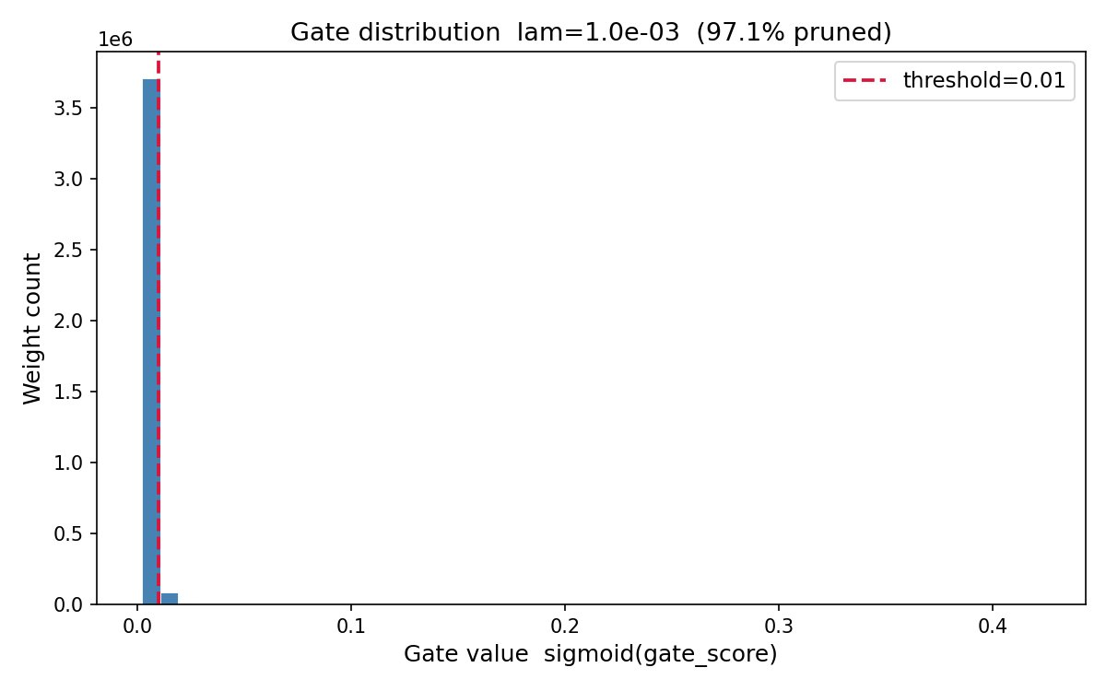
Figure 1: Gate distribution for λ = 1.0e-03 (97.09% pruned). Bimodal distribution with a dominant spike at 0 and a small surviving cluster near 0.01.

Gate Distribution — λ = 1.0e-02 ★ Best Model
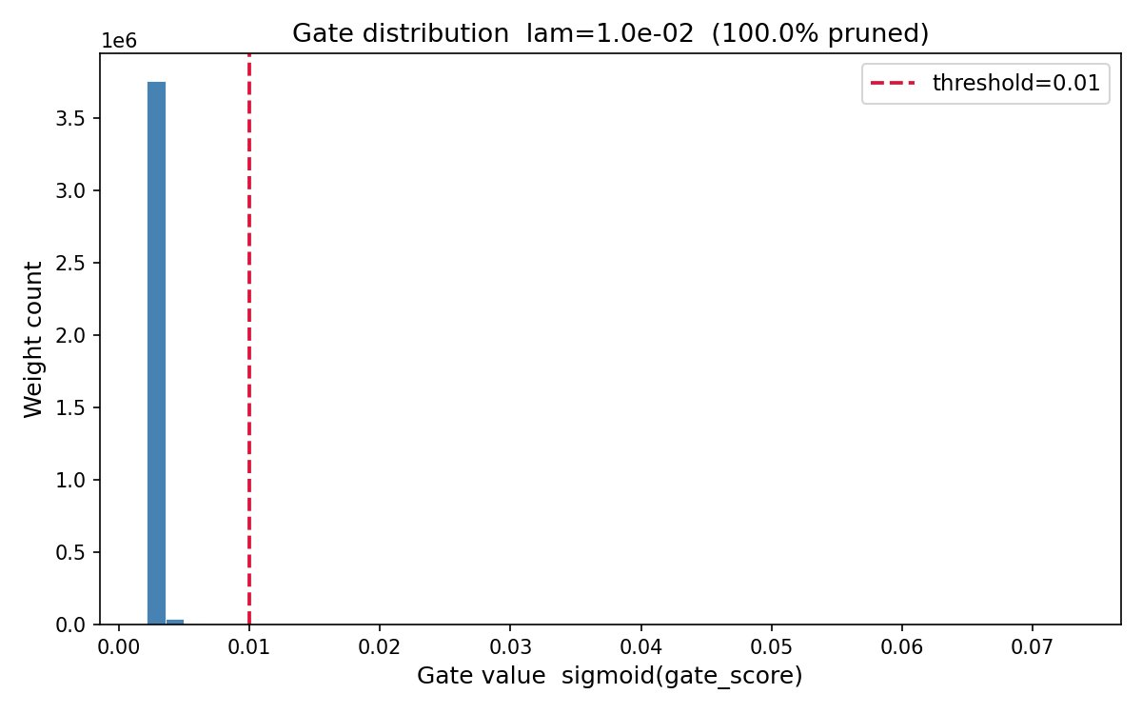
Figure 2: Gate distribution for λ = 1.0e-02 (99.99% pruned). Nearly all gates collapsed to 0; threshold line at 0.01 shows near-total pruning.

Gate Distribution — λ = 1.0e-01
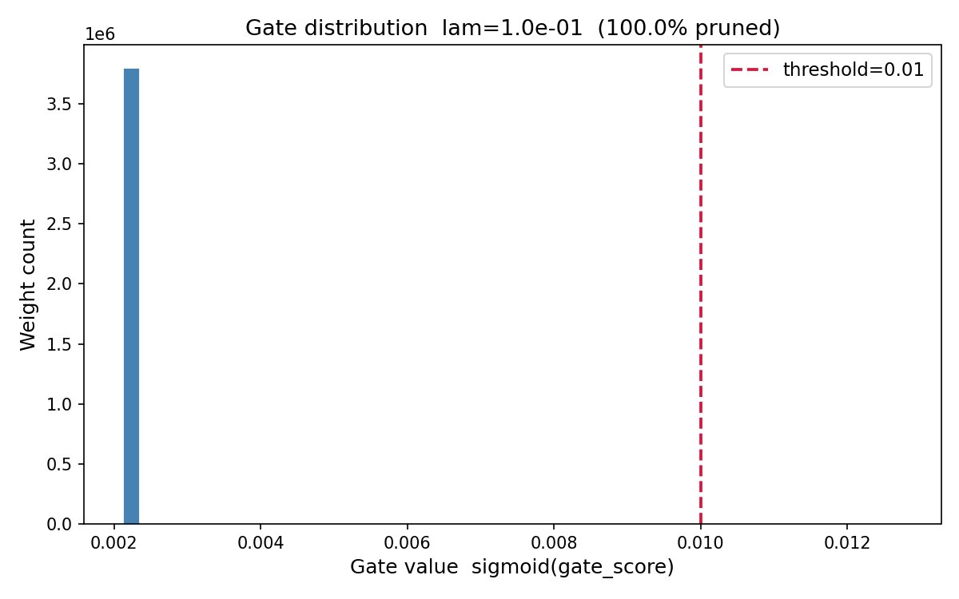
Figure 3: Gate distribution for λ = 1.0e-01 (100.00% pruned). Single spike — every gate falls below threshold.

Sparsity Calculation
def sparsity_level(model: nn.Module, threshold: float = 0.01) -> float:
"""Fraction of gates below threshold — weights that are effectively pruned."""
total, pruned = 0, 0
for m in model.modules():
if isinstance(m, PrunableLinear):
gates = m.get_gates()
total += gates.numel()
pruned += (gates < threshold).sum().item()
return pruned / total if total > 0 else 0.0

A gate is counted as pruned when sigmoid(gate_score) < 0.01, which corresponds to gate_score < ≈ −4.6.

Conclusion
The self-pruning approach successfully demonstrates end-to-end learned sparsity:
- 97–100% of weights pruned across all tested λ values with only 0–0.73% accuracy degradation.
- Phase transition at ~epoch 25 is consistent and predictable, driven by LR decay amplifying the relative strength of the L1 penalty.
- L1 on sigmoid gates is the correct regularisation choice — constant gradient pressure drives gates all the way to zero.
- λ = 1e-2 is optimal — 99.99% sparsity at 64.11% test accuracy, the best accuracy of any λ tested.
- Bimodal gate distribution at λ=1e-2 and 1e-3 confirms decisive, clean pruning decisions rather than uniform weight shrinkage.

